RONALD LEE BROWN
Email pilotronbrown@yahoo.com Cell 1-856-419-3233-GA Temporary
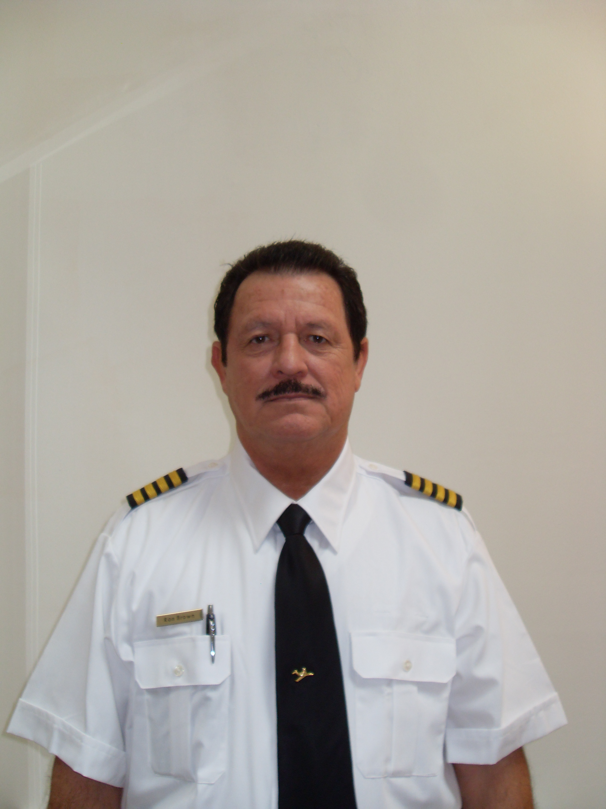
- ATPL USA #2208675, ATPL Australia #129860, PNG CPL #352470. Nigerian ATPL, IOM ATPL
- First class medical (completed July/2014)
- Flight Instructor Rating USA & Australia
- A and P License Cert. No. 2027843

- Summary of flying hours
Jet - 9058; PIC – 15,000; Total time - 18,158
Night Flying – 4920; Turboprop - 3170;
S.E.L. – 2185; Multi Engine (piston) – 2950
- GIV PIC CAE P135.293 & .297 02/2013 GIII PIC CAE P91 61.58 06/2011
CE-550 PIC SimCom P61.58 03/2014
- International Procedures Training
- No Violations/Accidents/Incidents / DUI’s -EVER

AIRCRAFT ENDORSEMENTS
Gulfstream GIIB/GIII AC&DC 2951 Hrs Gulfstream GIV 1363 Hrs
Citation CE-650 520 Jetstream J31/J32 SP 535
Citation CE-550 2037 Lear 45 510
Falcon 20 890 King Air 200 SP 816 Learjet 55/31A 370 Bandeirante E110 SP 780
Citation CE-560U 885 Beachcraft B65/80 800

EMPLOYMENT RECORD
- Capt. GIV P91/Citation (Contract) Riyadh, SA 02/2014-11/2014 Co-pilot GIV P135 Windsorjet, FL (Freelance) 02/2013-07/2013 Captain GIV P91 (Freelance) Triax Airline/Oranto Petr Nigeria 02/2012-06/2012
- Captain GIII/AC P91 Siarex Society/Skybird Chad/Nigeria 10/2010-10/2011
- Captain GII/III Universal Jet Charter, FL (Contract) P91/P135 NJ 02/2010-09/2010
- Captain GIV/GIII/GIIB P135 World Wide Jet Charter, NJ 05/2005-07/2009
- Captain LR-45/LR 55/31A P135 Avbase Aviation, OH 2003 /2005
- Captain CE-560U P135 Cederwood Development, OH 2001/2003
- Captain GIISP P135 Auster Aviation, IL 2000-2001
- Captain DA20 P135/Cargo Reliant Airlines, TN 1999-2000
- Base Manager/Captain DA 20/CE650/J31/E110 Australian Jet Charter 1992-1999
Shell/Mobil Oil Co. Based in the Far East of Russia for 6 yrs.
- Captain GIIB Consolidated Press Holdings , Sydney Australia 1989-1991
EDUCATION
Aeronautical College/ Sydney, Australia
Spartan Technical School, A&P License, Tulsa, OK

